**Universidad Americana**



***Algoritmos y estructuras de datos***

**Integrante:**

* **Gabriel Antonio Rojas Uriarte**
* **Gabriel Alejandro Garcia Angulo**

**Abril de 2025**

***Funciones internas, modulos y paquetes***

Ejercicio 1:

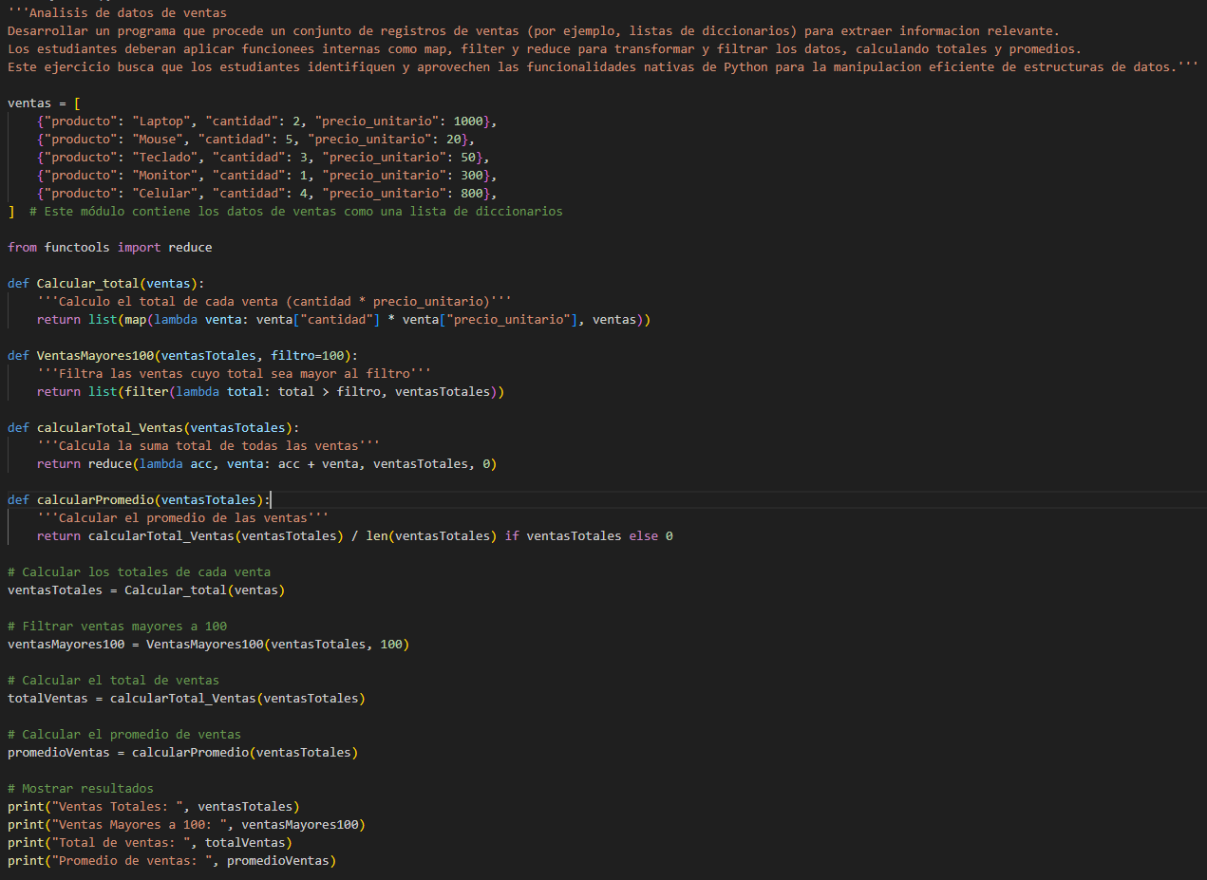

Terminal:

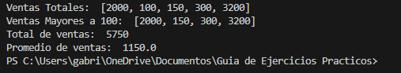

Ejercicio 3:



Terminal:

***Clases y objetos***

Ejercicio 4:

Terminal:

